AGENDA - Little Hoole Parish Council  Members of the Council are summoned to the Parish Council Meeting to be held on  Mon 10th Nov 2025 at 7pm  The Residents’ Lounge, Old Mill Court, Liverpool Old Road, Walmer Bridge, PR4 5QU  Paul Cafferkey, Clerk & Responsible Financial Officer | 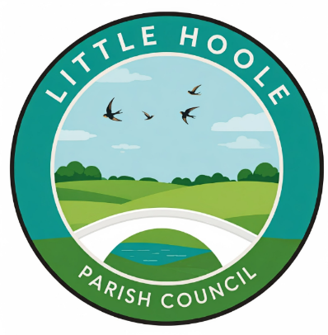
- Apologies for absence
- To agree the Minutes of the last Parish Council Meeting held on the 13th Oct 2025.
- To receive declarations of interest
- Matters arising from the minutes of last meeting
  - Public Time: to invite and listen to issues raised by members of the public.
  - Planning Applications:
    - 07/2025/00775/CLD. Shaunleigh Dob Lane Walmer Bridge PR4 4SU. Lawful Development Certificate for the erection of a detached outbuilding to be used as a garage and domestic storage
    - 07/2025/00801/DIS. 363A Liverpool Road Walmer Bridge PR4 5JS. Discharge of condition 11 (Surface Water Drainage) of planning permission 07/2023/00829/FUL
  - To approve the following transactions in the bank for Oct 2025.

  - Payments approved by email or pre-approved and retrospectively noted:
    - purchase of replacement pads for defibrillator £64.95 (excl VAT)
    - purchase of reflective pendants for pupils of Little Hoole Primary School.
    - Hire hall at Walmer Bridge Village Hall re public meeting with Police £33.00
    - A5 flyers for public mtg with Police £76.00.
  - Payments for approval - Clerk’s claim for Oct 2025 of 17.26 hours and postage expenses of £1.70.
  - To approve annual subscription of £84.99 for Microsoft 365.
  - Finance Statement as at 31st Oct 2025.
  - To discuss possible use of remaining CIL monies
  - Section 117 (Local Govt Act 1972) clarification.
  - To appoint Internal Auditor for 2025-26.
  - Initial discussions re Parish Council Precept for 2026/27
  - Update re vacancy for a Parish Councillor on Little Hoole Parish Council.
  - To discuss summer activities programme for 2026
  - Discussion re Bus Shelters
  - Update re grant to Little Hoole School PTA re playground markings
  - Update re drain on corner of Dob Lane and Liverpool Old Road.
  - Update re Christmas Tree & Christmas Lights
  - Update re Remembrance Sunday wreaths and lamp post poppies.
  - To discuss tree on Dob Lane Recreation Park re possible sculpture.
  - Update re Biodiversity Grant.
  - Update re nomination for The King’s Award for Voluntary Service.
  - Update re winter planting
  - Information and Updates.
  - Correspondence – none
  - To agree the date, time, and venue for the Dec 2025 meeting.
Members of the public are welcome to attend meetings to raise any relevant matters. Alternatively, if you cannot attend the meeting but wish to raise a matter or ask a question, this can be done on your behalf by contacting the Parish Clerk (Paul Cafferkey) via email clerk@littlehoole-pc.gov.uk or mobile phone 07966267186.
Visit the Little Hoole Parish Council Website https://www.littlehoole-pc.gov.uk or scan the following QR code.



Prepared and approved by Paul Cafferkey, Clerk – Little Hoole Parish Council,
4th Nov 2025

